Using Filezilla

Click the FileZilla icon to open FileZilla.

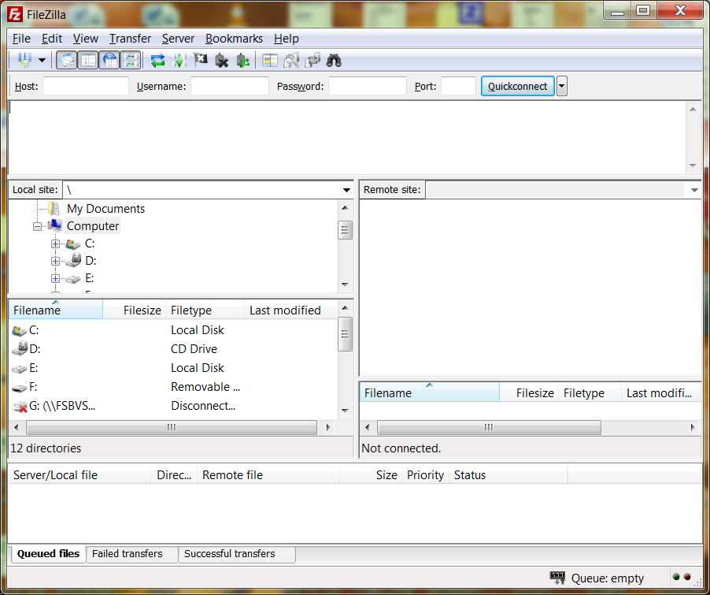

FileZilla workspace looks like the above.

Complete the Logon info as indicated below.
Host: webdivbus.swic.edu
Username needs to be completed with your username eg doej0000
Password is your password xxxxxxxxx
Select “Quickconnect” when info has been entered
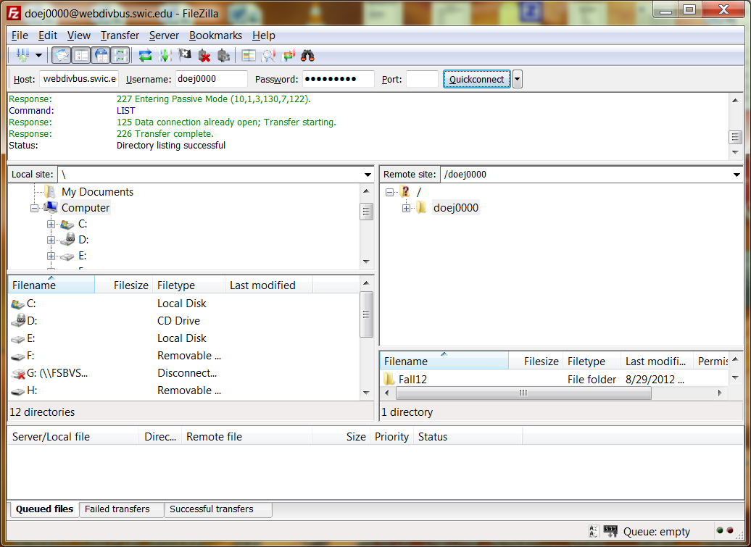

Click “Unblock” if this window displays
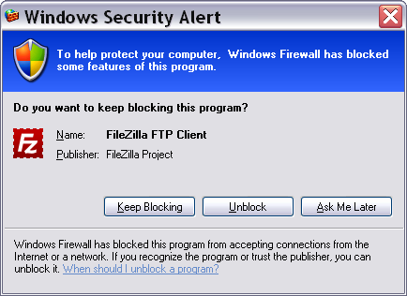
Locate where your “folder” is located that you want to upload to the server. Be sure to rename the folder so it is unique [for example, Chapter has been renamed to mycss3]
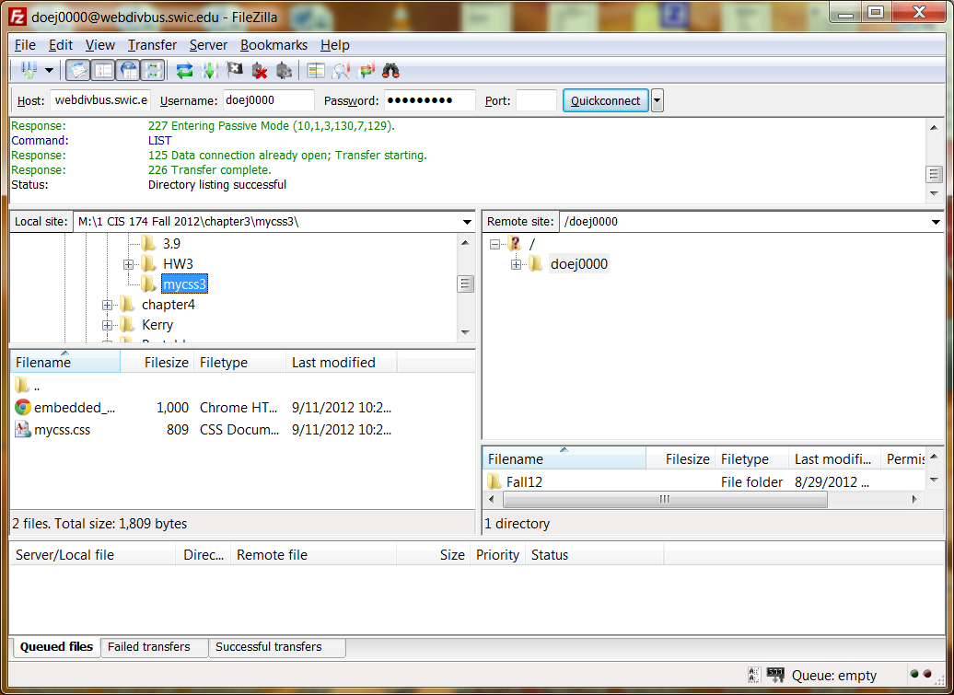

Prepare for the transfer:
- On the right side, under Remote site, expand the folder [Click on the + sign] with your username [doej0000 in this example]
- Open the semester folder [Fall12 in this example ~ you will be using Fall13]
- Open the folder which matches the class you are taking [CIS174-002 in the example below]

Now you are ready for the transfer:
- Drag your folder [for example mycss3] from the local site on the left to the remote site folder CIS174-002 on the right
- Files will upload
- If you do not see the uploaded folder, then click the +sign in front of the folder [CIS174-002 in this example]
- Refer to the image on next page.

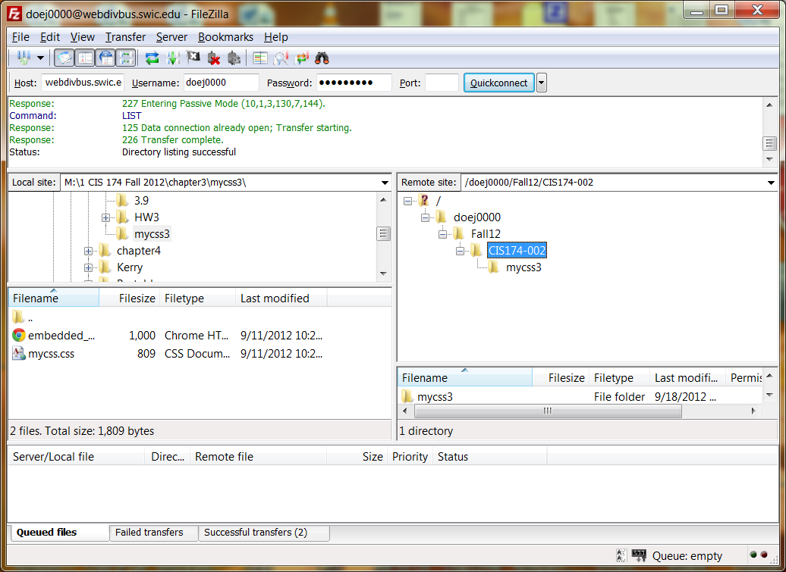

When finished, you should see your folder in its original directory and also on the SWIC server

To view your files on the server, go to: http://webdivbus.swic.edu/{User Name} i.e. http://webdivbus.swic.edu/doej0000 ~~~ see below
